GhostCore Project: VeilPiercer
Negative-Space Electromagnetic Detection
White Paper PoC
A concept paper and simulation proof of concept for detecting low-observable objects by measuring deficits, phase distortion, and interference anomalies in a known electromagnetic field.
Version | Status | Date
1.0 PoC | Concept validation | 2026-03-13

Core proposition. A low-observable object may suppress direct visibility in one band yet still leave a measurable wound in the field: missing energy, abnormal phase shift, or a broken interference pattern. The PoC detects that absence signature instead of waiting for a bright return.
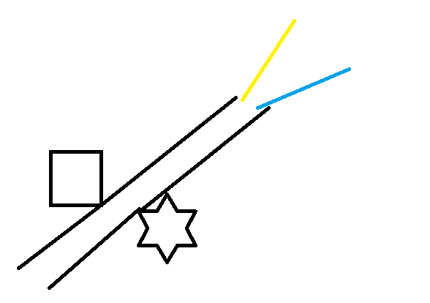
Figure 1. Concept sketch: the target is inferred from divergence and missing overlap in the expected propagation geometry.
1. Executive Summary
This paper translates the VeilPiercer concept into a software proof of concept for negative-space electromagnetic detection. Instead of relying on strong reflections from a target, the method first establishes an expected field pattern across a sensor plane and then scores deviations between the baseline and observed scene.
In the PoC, a two-source coherent field is simulated over a 2D grid. A hidden object is introduced not as a bright reflector but as a local attenuation and phase-distortion zone. The detector then computes three maps: missing energy relative to baseline, phase error relative to baseline, and a combined anomaly score. The result is a bounded detection region derived from field deficits rather than direct target visibility.
This is a concept-validation paper, not a claim of fielded performance. It demonstrates the sensing logic, the detection vocabulary, and a plausible analysis pipeline for later hardware experiments.
2. Problem Statement
Modern low-observable systems seek to defeat sensors by reducing direct returns in selected bands. A detector that asks only, 'What reflected back?' can therefore fail precisely when the target is designed to look faint. A more resilient framing is to ask, 'What should be present in this field that is now absent or distorted?'
That reframing matters because every physical object still interacts with fields. Even when a platform minimizes reflection, it can still absorb energy, alter phase, break coherence, perturb interference, shadow ambient illumination, or produce secondary signatures in adjacent bands. Negative-space sensing exploits those interactions.
3. Detection Concept
The VeilPiercer logic can be summarized as baseline–disturbance analysis. Multiple coherent sources illuminate a monitored volume. A receiver grid or distributed mesh records the expected superposition pattern under known conditions. Observations are then compared against the baseline to identify anomalous deficits and phase shifts.
Signal feature | What is measured | Why it matters
Missing energy | Expected amplitude exceeds observed amplitude | Suggests absorption, shadowing, or cancellation
Phase error | Observed local phase differs from baseline | Suggests path-length change or field distortion
Interference break | Superposition geometry no longer closes as expected | Suggests an object is disrupting coherence
4. PoC Architecture
The software PoC uses a simplified two-dimensional field model suitable for inspection and fast iteration. Two coherent emitters generate a baseline complex field over a square grid. A synthetic low-observable object is then inserted at a known location. Rather than modeling a large specular return, the object primarily attenuates the local field and shifts its phase, with only a weak diffuse halo to avoid an unrealistically perfect void.
The detector computes amplitude and phase from both the baseline and disturbed field. A normalized missing-energy map identifies where observed amplitude falls below expectation. A normalized phase-error map identifies where the observed field diverges in angle from baseline. A weighted anomaly score combines the two and is thresholded to produce a detection mask and bounding box.
• Generate baseline complex field from synchronized emitters.
• Insert a hidden-object mask with attenuation and phase shift.
• Measure the observed field on the sensor plane.
• Compute missing-energy and phase-error maps.
• Fuse maps into a normalized anomaly score.
• Threshold the score and bound the triggered region.
5. Simulation Parameters
Parameter | Value
Grid size | 220 × 220 cells
Sources | 2 coherent emitters
Wavelength | 22 grid units
Object model | Circular attenuation/phase-distortion region
Object radius | 24 grid units
Attenuation | 0.78
Phase shift | π / 2.7
Decision threshold | 0.28 anomaly score
6. PoC Result
In test runs, the anomaly score forms a contiguous region around the hidden object despite the absence of a strong direct reflection. The detection is therefore not driven by brightness; it is driven by inconsistency between the expected and observed field. The output is interpretable: a human reviewer can inspect the baseline amplitude, observed amplitude, missing-energy map, phase-error map, combined score, and final detection overlay.
This is the core outcome the PoC needed to show: a stealth-like object can be inferred from the bruise it leaves on the field. The result does not claim operational stealth defeat. It demonstrates that negative-space analysis is a coherent engineering path worth deeper testing.
7. Strengths, Limits, and Risk
• Treats absence as a measurable signal.  • Can combine amplitude and phase instead of relying on reflectivity alone.  • Naturally extends to multistatic and distributed sensor geometries.  • Produces maps that are explainable to operators and engineers. | • Simulation uses a simplified 2D field and idealized synchronization.  • No clutter, weather, multipath, or hardware timing error is modeled.  • The object model is synthetic and not tied to a measured material stack.  • Threshold tuning is scenario-dependent and may produce false positives.
8. Path to Hardware
The next phase should move from a field visualization PoC to a sensor-array experiment. A practical bench prototype would use multiple synchronized transmitters and receivers, controlled target materials, and repeatable clutter conditions. The objective would be to establish whether negative-space metrics remain separable under noise, motion, and imperfect calibration.
• Build a multistatic bench setup with synchronized RF nodes.
• Record baseline scenes and scenes containing absorbing and phase-shifting targets.
• Inject noise, occlusion, and multipath to test robustness.
• Compare single-band and multi-band anomaly fusion.
• Add temporal tracking to distinguish persistent targets from transient drift.
9. Conclusion
This white paper PoC shows that advanced stealth detection can be framed as anomaly detection in field behavior rather than simple target reflection. In practical terms: do not look only for what appears. Look for what should have been present in the field but is now missing, delayed, or broken.
That is the VeilPiercer proposition in its most grounded form: the target may hide from the eye, yet still betray itself by the geometry it wounds.
Appendix A. PoC Definition
The accompanying Python PoC generates a baseline field, applies a hidden-object disturbance, and produces missing-energy, phase-error, and combined anomaly maps. It is suitable for concept communication, design review, and algorithm discussion. It is not a substitute for calibrated laboratory measurements or deployable sensing hardware.

